**Course-End Project: Set Up a WordPress Instance for Your Organization**

This section will guide you to:

* Create a CloudFormation new stack
* Create an AMI of the WordPress instance
* Configure Auto Scaling to launch a new WordPress instance
* Configure the new WordPress instance to shut down automatically

**Step 1:** Create a CloudFormation new stack

* From the EC2 dashboard, select **CloudFormation**
* Select **Create New Stack**
* From the **Choose a template** section, choose **Select a sample template**
* From the drop-down, choose **WordPress blog,** and then click on the **Next** button

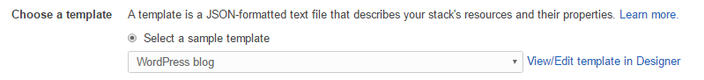

* Enter a name in the **Stack Name** field
* Change the **Instance Type** to **T2.micro**
* In the **KeyName** section, select a key, and then click on the **Next** button

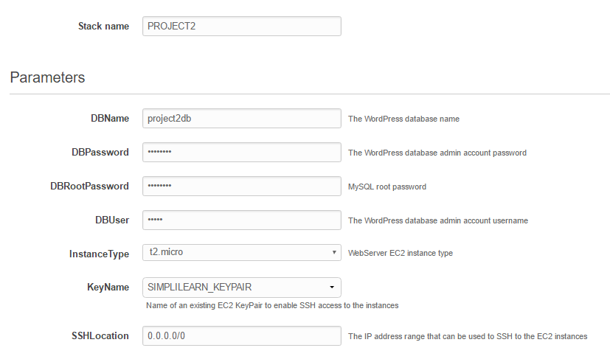

* Give your instance a meaningful tag name, and then click on the **Next** button
* Review the settings, and then click on the **Create** button
* Wait until the status of the stack changes from **Pending** to **CREATE_COMPLETED**



**Step 2:** Create an AMI of the WordPress instance

* Switch to the **EC2 dashboard** and verify that your new instance is available for use



* Select the new instance and click on the **Actions** button
* Select the **Image** option
* Click on the **Create Image** button
* Enter an **Image Name** and **Image description**, and then click on the **Create Image** button

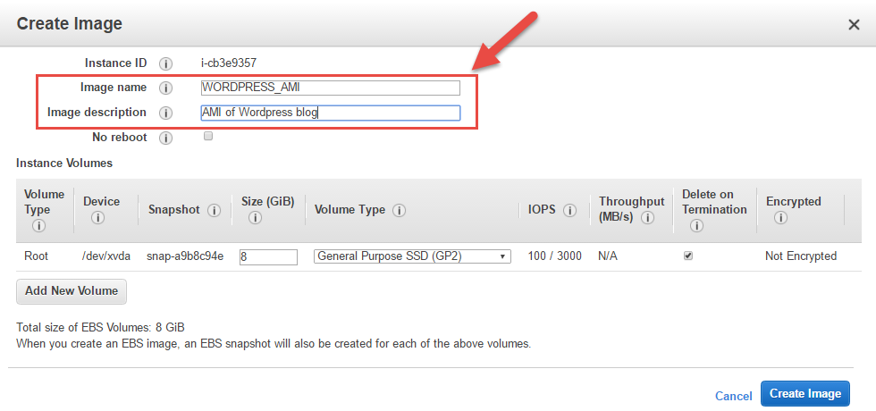

* Switch to the **AMI dashboard** and wait until the status of your new AMI changes from **pending** to **available**



**Step 3:** Configure Auto Scaling to launch a new WordPress instance

* Switch to the **Auto Scaling Groups** dashboard, and then click on the **Create Auto Scaling Group** button
* Click on the **Create launch configuration** button
* On the **Choose AMI** page, click on the **My AMIs** button, and then select your newly created AMI

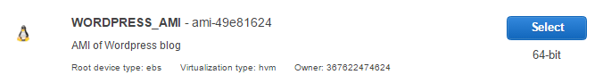

* On the **Choose Instance Type** page, select **T2.micro,** and then click on **Next: Configure Details**
* Enter a suitable **Name** for the launch configuration, and then click on **Next: Add Storage**
* Click on **Next: Configure Security Group**
* Choose a suitable Security Group or select the Security Group that was created as part of your CloudFormation stack
* Click on the **Review** button
* Review the settings, and then click on **Create launch configuration**
* Select your key, and then click on **Create launch configuration**
* You can now use the new launch configuration to create a new WordPress instance during the working hours (9 AM - 6 PM).

**Step 4:** Configure the new WordPress instance to shut down automatically

* Click on **Create Auto Scaling group**
* Enter a **Group Name** and set the **Group Size** as **zero**
* Select a subnet where you want to create the new instance

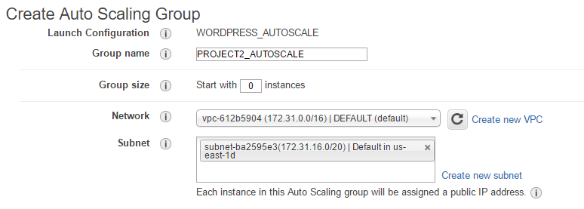

* Select **Keep this group at its initial size**
* Click on **Next: Configure Notifications**
* Click on **Next: Configure Tags**
* Enter suitable tags, and then click on **Review**
* Review the settings, and then click on **Create Auto Scaling group**
* Click on **View your Auto Scaling groups** and select the new group
* Click on **Actions,** select **Edit,** and then set the **Desired** value to **0**, **Min** value to **0**, and **Max** valueto **1**

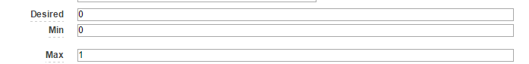

* Click on the **Scheduled Actions** tab, and then click on **Create Scheduled Action** to create the scheduled actions
* Enter a **Name**, for example, **SCALEUP_9AM**, set the **Desired Capacity** as **one**, and then set the time when you want the job to run
* The time is in the **UTC** format, so you need to set it to the **UTC** equivalent of 9 AM for your time zone.
* Once complete, click on the **Create** button

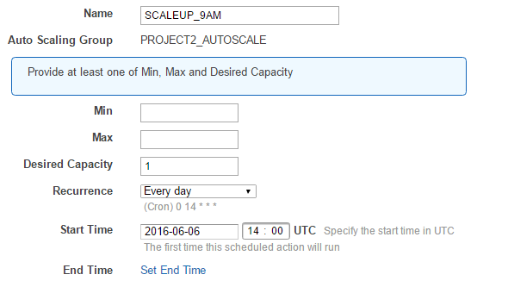

* Enter a **Name**, for example, **SCALEDOWN_6PM**, set the **Desired Capacity** as **zero**, and then set the time when you want the job to run
* The time is in the **UTC** format, so you need to set it to the **UTC** equivalent of 6 PM for your time zone.
* Once complete, click on the **Create** button

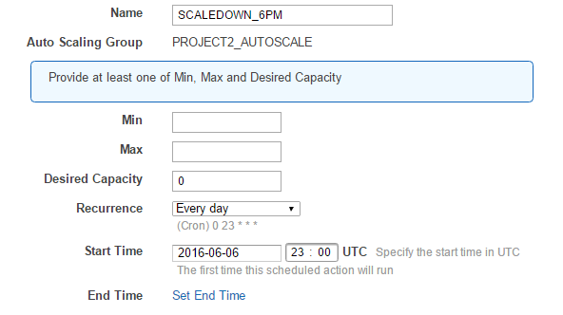

* Verify that the actions have been created successfully

